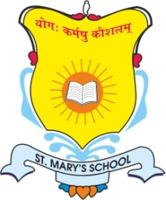
ST. MARY’S SCHOOL

231/A Knowledge Park -5 Greater Noida

Circular No: SMS/GN/Pre-Nur-VIII/- 42 Date: 15.05.24

2nd PTM Circular

Dear Parents,
Greetings!!

We believe in partnering with parents to make learning a wonderful & enriching experience.
It’s time to discuss academic progress across classes during 2nd Parent Teacher Meeting (PTM) for Pre-Nur-VIII on:-

Day/Date: - Saturday, May 18, 2024
Timings: - 8:30 am – 12:00 Noon

- Kindly note that PT 1 answer sheets will be shown to parents of grade I-VIII, therefore it is mandatory for parents to attend this PTM.
- Student must accompany their parents & attend PTM in regular uniform as per the slot given by CT’s
- Pre-Primary T 1 will be scheduled in July, In case parents have any doubt related to T 1 must discuss with their respective class teachers.
- It is mandatory to submit students pending documents like Aadhar Card, Birth certificate and TC etc. if not submitted at the time of admission.
- Summer break will start from Monday May 20, 2024 till June 30, 2024 for all classes.
- School will reopen on Monday, July 1, 2024 for all.
- Parents are requested to clear Qtr 1 (April-June) pending fee before 18th May to avoid fine@ Rs. 50 per day.

Regards
Principal
St. Mary’s School
Greater Noida

