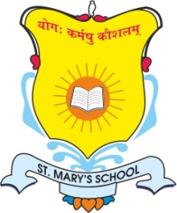
ST. MARY’S SCHOOL

231/A Knowledge Park -5 Greater Noida

Circular No: SMS/GN/Pre-Nur-VIII/43 Date: 15.05.24

Summer Holidays Circular

Dear Parents,

Greetings!!

Long awaited summer holidays are here again. We would like to wish each one of you Happy Holidays & fun filled family time!

Kindly note that school will remain closed from Monday, May 20, 2024 till Sunday
June 30, 2024 for Summer Holidays & will reopen on Monday, July 1st, 2024 for all classes from Pre-Nur till grade VIII.
However the school office will be working during summer break from 9:00 am – 3:00 pm.

In order to keep our students well engaged during the holidays, we are sending the Summer holiday’s homework. These assignments will help them to revise all the concepts done so far.

Important

- We request parents to encourage your ward to complete home assignments on their own and submit on time.
- Parents are requested to spend quality time together, go out to nature walk, let them meet their grandparents, cousins and understand family bonding.
- Encourage them to help you in kitchen and kitchen garden.
- It is suggested to have prayer time and story time every day.
- Avoid giving them mobile, gadgets and limit the screen time.
- Encourage them to eat homemade and healthy food every day.
- Encourage your ward to celebrate World Environment day, Father’s day, International Yoga day and share photographs with their Class teachers.

HAPPY HOLIDAYS!!

Regards,

Principal
St. Mary’s School
Greater Noida

