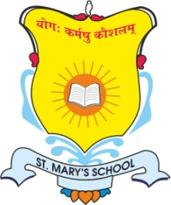
ST. MARY’S SCHOOL

231/A Knowledge Park -5 Greater Noida

Circular No: SMS/GN/Pre-Nur-VIII/- 44 Date: 20.06.24

Dear Parents,
Greetings!!
Yoga is an invaluable gift of ancient Indian tradition .The word Yoga is derived from the Sanskrit word Yuj meaning to join or to unite symbolizing the unity of minds & body and a holistic approach to health and well-being.
On the occasion of International Yoga Day on 21st June, we have planned the following class wise competitions:-
S.NO. | CLASSES | COMPETITION
1. | PRE-PRIMARY TO CLASS II | FAMILY YOGA (1 min. video max.)
2. | CLASS III TO CLASS V | SURYA NAMASKAAR (Photo Collage of all 12 poses)
3. | CLASS VI TO CLASS VIII | SLOGAN WRITING/POSTER MAKING (Theme:-Importance of Yoga)

Certificates will be provided to best entries.

Entries/Videos/Photos must reach to their respective class teachers by Monday, 24th June 2024.

Regards
Principal
St. Mary’s School
Greater Noida

